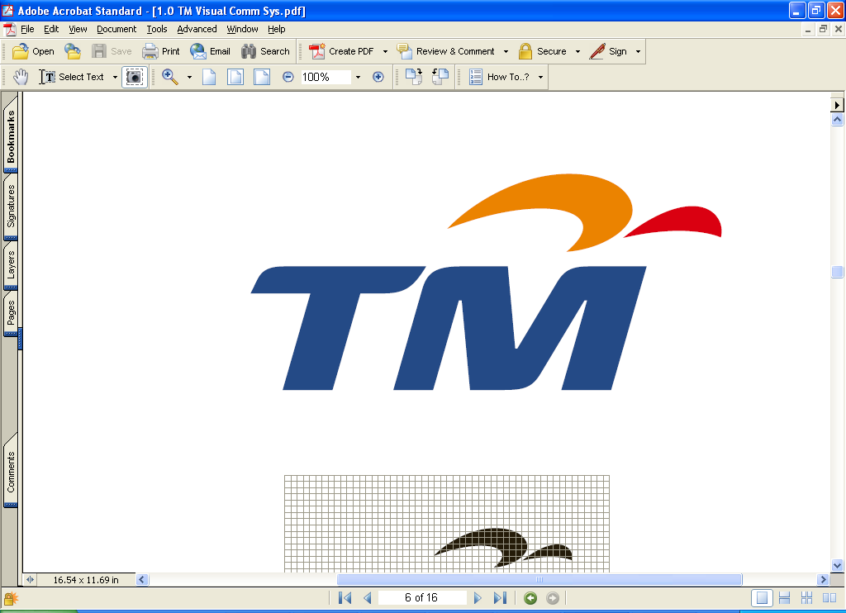

TELEKOM MALAYSIA BERHAD

(Company No. 128740-P)
(Incorporated in Malaysia under the Companies Act, 1965)

NOTICE OF EXTRAORDINARY GENERAL MEETING

NOTICE IS HEREBY GIVEN that the Extraordinary General Meeting (“EGM”) of Telekom Malaysia Berhad (“TM” or the “Company”) will be held at Hall 4, Ground Floor, Kuala Lumpur Convention Centre, Kuala Lumpur City Centre, 50088 Kuala Lumpur, Malaysia on Tuesday, 16 May 2006 at 11.00 a.m., or immediately after the conclusion of the Company’s 21st Annual General Meeting (“AGM”), whichever is later, or at any adjournment. The AGM will be held at the same venue and on the same day at 10.00 a.m., or at any adjournment. The EGM will be held for the purpose of considering and, if thought fit, passing with or without modifications, the resolution set out below:

ORDINARY RESOLUTION

EMPLOYEES SHARE OPTION SCHEME FOR ELIGIBLE DIRECTORS AND EMPLOYEES OF DIALOG TELEKOM LIMITED (FORMERLY KNOWN AS mtn networks (PRIVATE) LIMITED), TM’S SUBSIDIARY, AND ITS ELIGIBLE SUBSIDIARIES

“THAT the establishment of the employees share option scheme (“Dialog ESOS”) for eligible Directors and employees of Dialog Telekom Limited (formerly known as MTN Networks (Private) Limited) (“Dialog”), TM’s subsidiary, and its eligible subsidiaries (“Dialog Group”) under which options will be granted to eligible Directors and employees of the Dialog Group to subscribe for ordinary shares of Rs1 each in Dialog, in accordance with the Bye-Laws of the Dialog ESOS as set out in Appendix I of the Circular to shareholders dated 29 April 2006, be and is hereby approved and ratified;

AND THAT TM’s Board of Directors be and are authorised to approve any modifications and/or amendments to the Dialog ESOS from time to time provided that such modifications and/or amendments are effected in accordance with the provisions of the Bye-Laws of the Dialog ESOS and to do all such acts and to enter into all such transactions, arrangements, agreements, deeds or undertakings and to make rules or regulations, or impose such terms and conditions or delegate part of its powers as may be necessary and/or expedient in order to give full effect to the Dialog ESOS.”

BY ORDER OF THE BOARD

Wang Cheng Yong (MAICSA 0777702)
Zaiton Ahmad (MAICSA 7011681)
Secretaries

Kuala Lumpur, Malaysia
29 April 2006

Notes:

- A member entitled to attend and vote at the above Meeting is entitled to appoint a proxy to attend and vote in his/her stead. A proxy need not be a member of the Company and the provisions of Section 149(1)(b) of the Companies Act, 1965 shall not apply to the Company.

- A member shall not be entitled to appoint more than two (2) proxies to attend and vote at the same meeting provided that where a member of the Company is an authorised nominee as defined in accordance with the provisions of the Securities Industry (Central Depositories) Act, 1991, it may appoint at least one (1) proxy in respect of each securities account it holds with ordinary shares of the Company standing to the credit of the said securities account.

- Where a member appoints two (2) proxies, the appointments shall be invalid unless the proportion of the holding to be represented by each proxy is specified.

- The instrument appointing a proxy shall be in writing under the hand of the appointer or his attorney duly appointed under a power of attorney or if such appointer is a corporation, either under its common seal or under the hand of an officer or attorney duly appointed under a power of attorney.

- A corporation which is a member, may by resolution of its Directors or other governing body authorise such person as it thinks fit to act as its representative at the Meeting, in accordance with Article 92 of the Company’s Articles of Association.

- The instrument appointing the proxy together with the duly registered power of attorney referred to in Note 4 above, if any, must be deposited at the office of the Share Registrars, Tenaga Koperat Sdn Bhd, 20th Floor, Plaza Permata, Jalan Kampar, Off Jalan Tun Razak, 50400 Kuala Lumpur, Malaysia not less than 48 hours before the time appointed for holding of the Meeting or any adjournment thereof, or, in the case of a poll, not less than 24 hours before the time appointed for the taking of the poll.

